**Topics: Class, Object and Function**

1. Write an Employee class in python to store the following information. Create an object of the class for each employee (row).

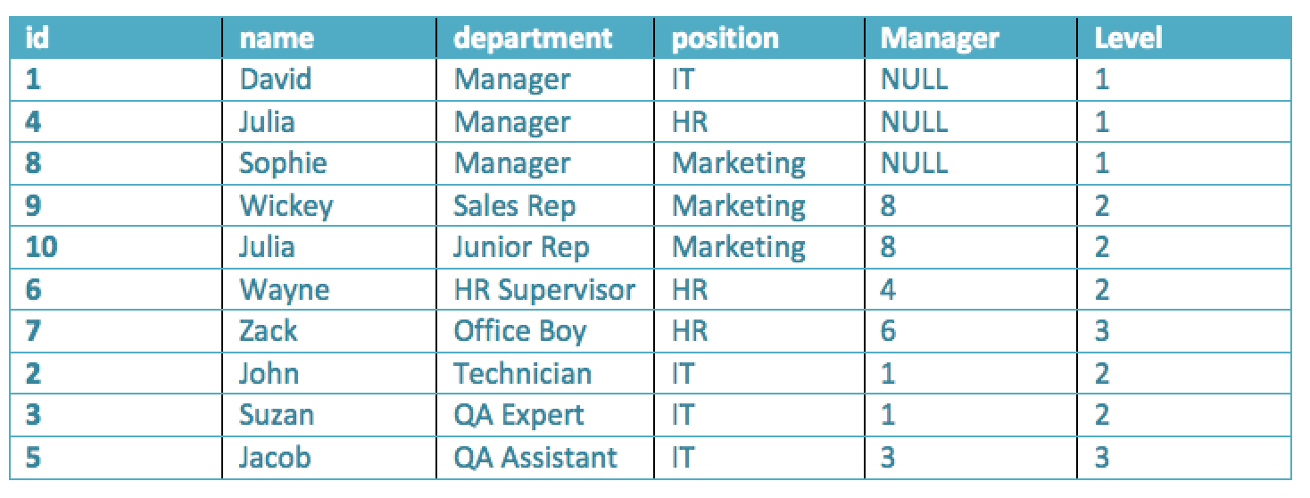

1. Write a Bank Account class in python to manage the account of the users. A user can deposit and withdraw money from his/her own account based on availability. Moreover, the account stores the following information

Instance variables:

* 1. Name of the account
  2. Account number
  3. Current Balance

Methods:

1. Deposit
2. Withdraw
3. Show Balance

Note: The above information should be provided at the time of account creation.

1. Write a python function to calculate the sum of the following series:

log(1) + log(2) + log(3) + …. + log(n) = ?

Note: The function takes the value of “n” as parameter and returns the sum.

1. Write a python class to build a simple calculator which can perform the following operations:
   1. a + b
   2. a - b
   3. a * b
   4. a / b
   5. Square root (a)
   6. Round (a)
   7. Power (a, b)
   8. log (a, base)
   9. Sin (angle in degrees)
   10. Cos (angle in degrees)
   11. Tan (angle in degrees)
   12. factorial (a)
   13. Percentage
   14. mod

The calculator can store the last output and show whenever the user calls it. Just like the **Ans** button on a real calculator.

1. Write a Credit Card class in python. A user can cash out (debit) money or pay shopping bills from his/her own card based on availability or limit. Initially, a credit card holder gets 100000 taka limit. The user has to pay back to the credit card bank.

Moreover, the account stores the following information

Instance variables: (information should be provided at the time of account creation)

* 1. Name of the credit card holder
  2. Credit card number
  3. Current Balance
  4. Max limit

Methods:

1. Deposit
2. Debit
3. Show current balance
4. Pay bill

6. Write a python class to calculate the area of the geometric shapes. The class has the following functionalities: Calculate the area of

1. Triangle
2. Square
3. Rectangle
4. Parallelogram
5. Rhombus
6. Surface area of Cylinder
7. Surface area of Cube
8. Surface area of Sphere

7. Write a python class for calculating the motion of a moving object by using the following equations

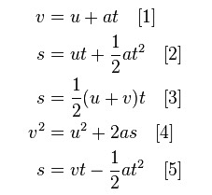

8. You are implementing a university management system for UAP. At some point you need to implement a student class to represent each and every student. Now, write a python class for student class with necessary attributes and methods.

Coding test guidelines:

1. Open a new file in google colab. Name of the file: B1_CT_4_ID

2. Share the file with me ([tsr@uap-bd.edu](https://mail.google.com/mail/?view=cm&fs=1&to=tsr%40uap-bd.edu&authuser=0))

3. Make sure your webcam is on during the test. (let me know if you have any problem, I will provide another question set)

4. Submit in the classroom properly. (from google drive)